,,
Dave Thomas
Mayor
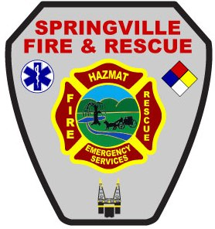

Richard Harvey
Fire Chief

CITY OF SPRINGVILLE
FIRE & RESCUE DEPARTMENT
Fire Chief Office
200 Walker Drive
P.O. Box 919
Springville, Alabama 35146
Telephone: (205) 467-0841
Facsimile: (205) 467-2706
EMAIL: rharvey@cityofspringville.com

OUTDOOR BURNING GUIDELINES FOR CONTRACTORS

Outdoor burning within the City Limits of Springville is regulated by local Ordinance 2014-02.

In accordance with this ordinance, the burning of construction debris is prohibited. Contractors are required to provide a container or other approved method for removing debris from their job site.

During the winter months, fires set in salamanders or other non-combustible devices used for outdoor heating is allowed without the need for a permit. Fuels must be appropriate for the device and be operated in a manner so as not to cause a public nuisance. A public nuisance would be from foul odor, or excessive smoke. Clean, un-treated wood may be burned in a non-combustible container. No trash, garbage, rubber, plastic or other refuse or synthetic materials may be burned.

Open burning of vegetation or untreated wood may be conducted if it is generated by clearing or maintaining land, or from demolition if all conditions in Section 2 (b) of Ordinance 2014-02 are met and upon receipt of a written permit from the Springville Fire Department. Conditions include but are not limited to:
- Burning must take place on the property on which the fuels originate.
- Burning must be at least 500 feet from the nearest occupied dwelling not on the property where the burning is conducted.
- The burning must not create a traffic hazard.
- Only vegetation and untreated wood may be burned.
- Initial burning may be conducted only between the hours of 8:00am and 3:00pm. No combustible materials may be added between 3:00pm and 8:00am the following days.
- Burning shall be conducted only when there is good ventilation and prevailing wind direction is away from any built-up area in the vicinity.
- Fire shall be attended at all times.
Permits are issued for no longer than 72 hours and must be renewed while burning is taking place. Permit may be revoked or suspended at any time.

If you have specific questions, need additional information, or to obtain a permit, you can call (205) 467-2703.

