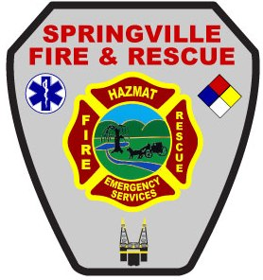
Dave Thomas
Mayor

Richard Harvey
Fire Chief

CITY OF SPRINGVILLE
FIRE & RESCUE DEPARTMENT
Fire Chiefs Office
200 Walker Drive
P.O. Box 919
Springville, Alabama 35146
Telephone: (205) 467-2703
Facsimile: (205) 467-2706
EMAIL: rharvey@cityofspringville.com

Firefighter / Paramedic
Springville Fire Department is accepting applications for Part-Time Firefighter / Paramedics. Position if for regular shift every 6th day with potential for additional shifts as available. For additional information contact Captain Graham Darnell or Fire Chief Richard Harvey at (205) 467-2703.

JOB QUALIFICATIONS
All personnel are required to be at least (21) years of age and have a high school graduation certificate or equivalent. In addition, all personnel are required to have a valid State of Alabama Driver’s License. Applicants must possess the following Certifications:

- Current CPAT (Candidate Physical Ability Test) Verification of Successful Completion Form
- Firefighter I/II Certification recognized by the Alabama Fire College preferred.
- Licensure by the State of Alabama at the EMT-Paramedic Level preferred or currently enrolled in Paramedic program.

BENEFITS INCLUDE
- Starting salary of $21,610/year ($15.98/hr.) for licensed/certified Paramedics.
- Tier I RSA Retirement
- 24/120 work schedule
- Enhanced AFRBP Cancer policy
- AFLAC supplemental insurance available
- City provided Group Term Life Insurance

Applications can be obtained online at www.cityofspringville.com or can be picked up at Springville City Hall located at 160 Walker Drive, Springville, AL 35146. Completed applications may be emailed to rharvey@cityofspringville.com or returned to:
Springville Fire & Rescue P.O. Box 919 Springville, AL 35146

